ID: 472-24 E
Cyber Protection in Infrastructures
Effectively Protecting Cyber Secured Operation of Power Utilities
אמצעי הגנה יעילים לאבטחת סייבר עבור חברות חשמל ואנרגיה
Daniel Ehrenreich
Secure Communication and Control Experts, Israel
daniel@scce.co.il 054-9151594
Achieving top level cyber security for industrial automation systems shall be the top priority at every organization dealing with manufacturing, utilities and other operations that involve physical processes. Consequently, the term “CI-Critical Infrastructure” is often mentioned in conjunction with Industrial Control Systems (ICS), Operation Technology (OT) and Supervisory Control and Data Acquisition (SCADA) systems, which manage the operation of power generation and the distribution, oil and gas pipelines, etc.
When referring to cyber security incidents directed to harming a power utility, we must realize that an attack might come from many directions and might cause severe damage to the industrial facility. The impact might be an outage, damage and risking lives. In depth understanding the “attack surface” and the “attack vector” terms may help you identifying security vulnerabilities in your facility and allow you acting instantly and effectively to minimize the damage caused by the cyber incident. To achieve these goals, the assigned teams must be trained in the control system and the communication media in each operation zone. In this paper we focus on the main topics for protecting power utilities.
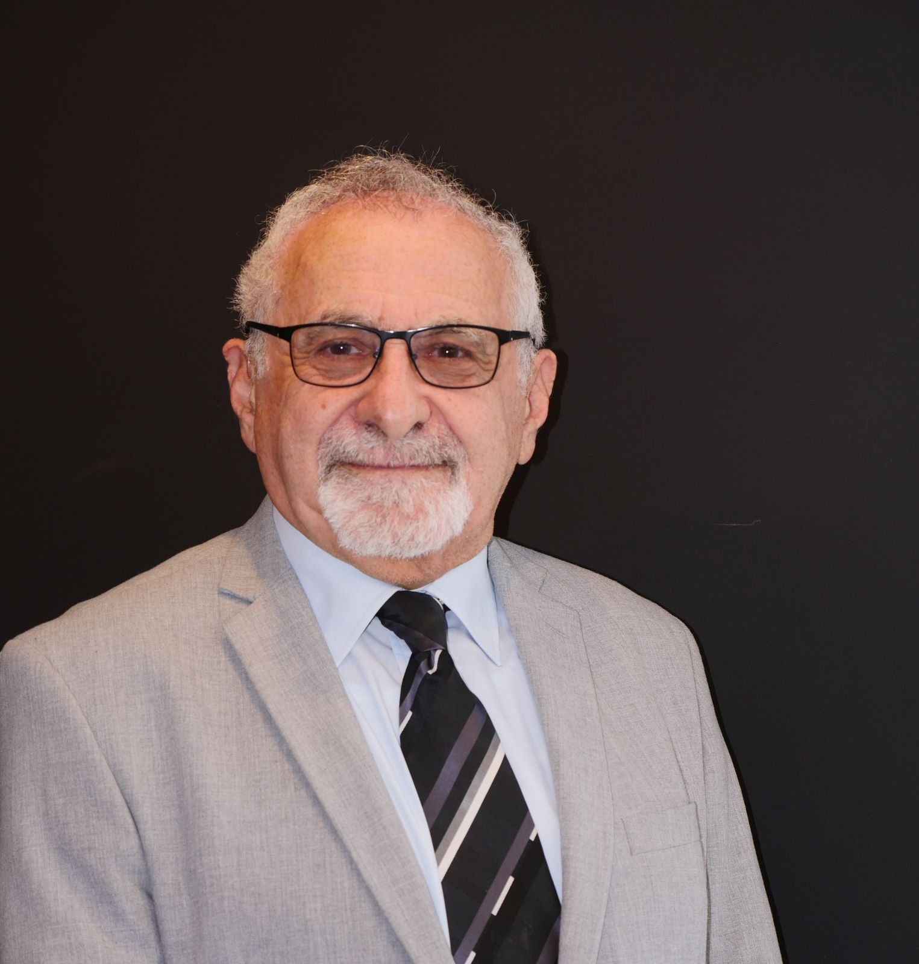
Daniel Ehrenreich, BSc. is a consultant and lecturer acting at SCCE- Secure Communications and Control Experts, and periodically teaches in colleges, training industrial organizations and presenting at conferences on the integration of cyber defense with CI operations; Daniel has over 33 years of experience with ICS-OT for electricity, water, gas, and power plants as part of his activities at Tadiran, Motorola, Siemens, and Waterfall Security. Daniel delivered keynote speeches at multiple conferences worldwide and is an active member of the ISA-IEC 62443 standard organization since 2020a.

